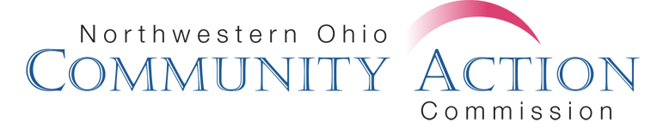
CDL Reimbursement Form

Driver Name ____________________________________ Date _____________

___ Pre-Service Class $85.00 ___ CDL Testing Receipt (Perrysburg) $115.00
----OR----
___ Permit $28.50 ___ CDL testing receipt (Findlay) ($55 + 1.75 CC fee)
___ CDL License $43.50

Staff Signature ________________________________ Total Cost __________
Transportation Signature ____________________________ Coding _____________

I understand that signing this agreement I will be required to pay all or a portion of the CDL Process back to NOCAC per the terms of the current Union contract.

